Here are similar questions designed for Exercise Sheet 4:

Implementation of DBMS
Exercise Sheet 5 from sheet 4
Klingemann, WS 2024 / 2025

- Suppose that we have 8192-byte blocks to store records of 250 bytes each. Each block has a header consisting of a 64-byte block ID and a 2-byte pointer table for offsets of records within the block. Each time a record is deleted, its pointer is replaced with a tombstone. If the block is initially empty, how many records can be inserted before the block is completely full?
- A data file contains 256 records. The records and blocks follow the configuration described in Exercise 1. How many blocks are required for the data file if:
a) Spanned storage is used.
b) Unspanned storage is used.
- Suppose we manage a sequential data file with 512 records, using overflow blocks to handle insertions. Assume the primary blocks are initially 75% full. If new records are inserted randomly, how many records must be inserted before the average number of blocks (including overflow blocks) that need to be examined for a lookup reaches 3? Assume the search starts at the primary block and continues through the overflow chain until the record is found.
- Blocks can store either five records or 20 key-pointer pairs. Given n, the number of records, calculate the minimum number of blocks required for:
a) The data file.
b) A dense index.
c) A sparse index.
You may ignore inaccuracies caused by rounding.

- Consider a block of 4096 bytes used for storing records of size 200 bytes each. The block header is 32 bytes, and an offset table requires 2 bytes per record.
a) How many records can the block store under unspanned storage?
b) If records are deleted at random and tombstones are used, how does this affect the total capacity for new records after 25% of the records have been deleted?
- Suppose a file contains 1 million records and uses a primary index with key-pointer pairs. Each block stores 128 key-pointer pairs, and the key is 8 bytes while the pointer is 4 bytes. Calculate:
a) The number of blocks required for the primary index.
b) The number of blocks required for a sparse index if each sparse key points to a block in the primary index.
- Imagine you are working with a database system where records of variable lengths are stored using a slotted-page structure. Each slot pointer requires 2 bytes, and the block header is 48 bytes. A block has a total size of 2048 bytes. How many variable-length records can be stored in a block if the average record size is 200 bytes?
- Consider a block of 8192 bytes with a block header of 128 bytes and a record format as follows:
  - 4-byte integer ID
  - 8-byte double value
  - 2-byte short value
Assume records must align to 4-byte boundaries. How many records can be stored in a single block?
- Discuss the implications of using dense vs. sparse indexes for a database with 10 million records. Consider factors such as the size of the index, lookup time, and block access during searches.
- A file contains nnn records, and a secondary index is used to support range queries. Each key-pointer pair in the index requires 12 bytes. If the block size is 4096 bytes, calculate the number of blocks required for the secondary index and discuss how the index structure affects range query performance.

These questions are designed to build upon your understanding of DBMS concepts, focusing on record storage, indexing, and block management. Let me know if you’d like further refinements or additions!

Here are two similar questions inspired by the given first question in sheet-4:

Question 1:
Suppose we have 8192-byte blocks in which records of 200 bytes are stored. Each block includes a header requiring 128 bytes and an offset table that uses 4-byte pointers for each record. Every week, two records are deleted (replaced by tombstones in the offset table), and three new records are inserted. If the block starts empty, how many weeks will it take until the block cannot store any more records?

Question 2:
A database uses 512-byte blocks to store records of 50 bytes each. Each block includes a header requiring 16 bytes and a pointer table with 2-byte pointers for each record. If a record deletion replaces its pointer with a tombstone, and every day two records are deleted and four new records are inserted, how many days will it take before the block is full and no further records can be added?
Solutions
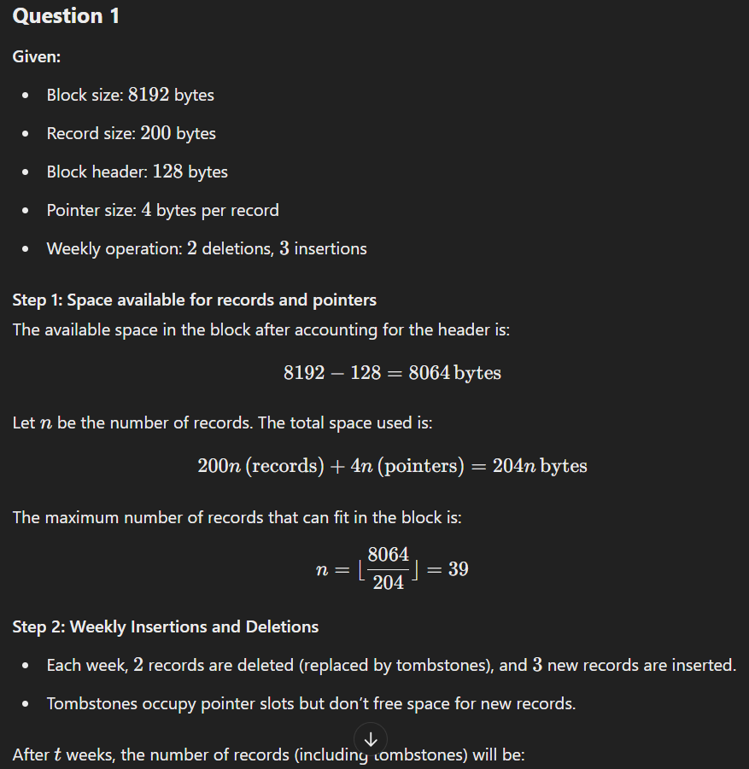
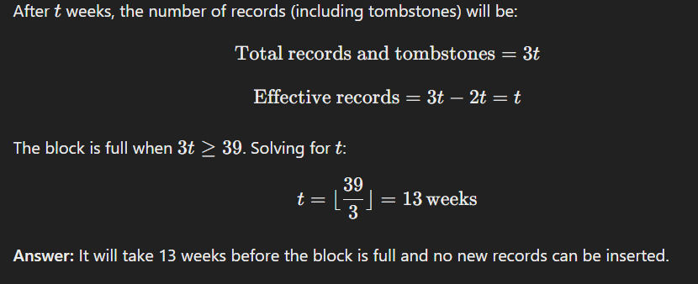

Question 2:
A database uses 512-byte blocks to store records of 50 bytes each. Each block includes a header requiring 16 bytes and a pointer table with 2-byte pointers for each record. If a record deletion replaces its pointer with a tombstone, and every day two records are deleted and four new records are inserted, how many days will it take before the block is full and no further records can be added?
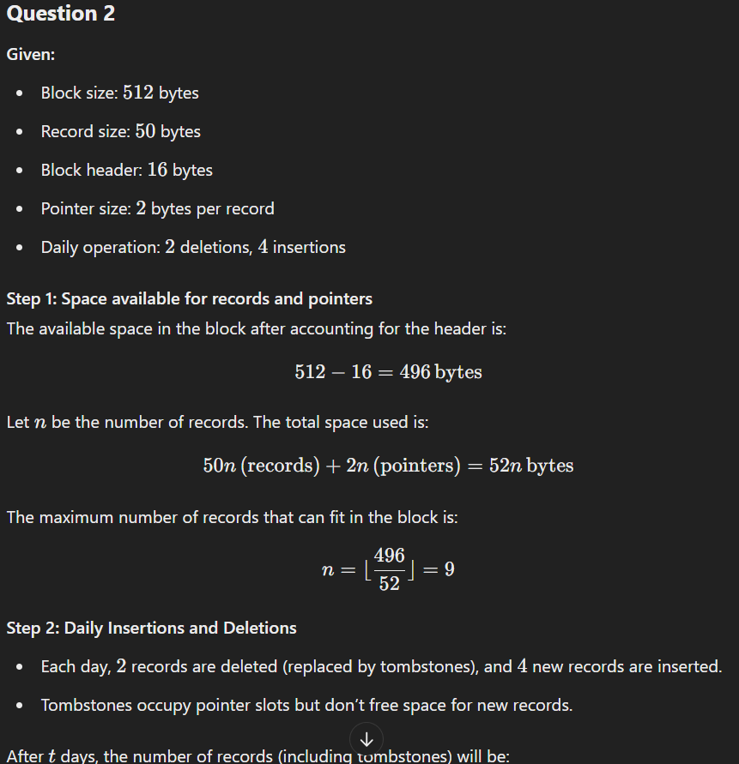
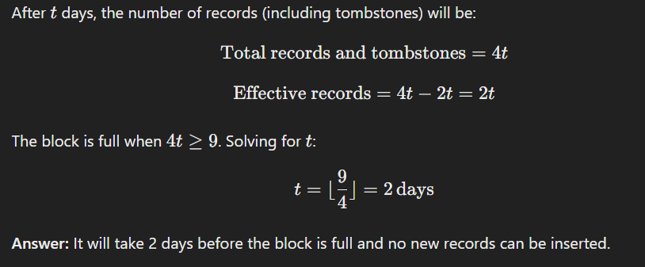
Here are two new questions inspired by the given Q.2 in Sheet-4 example:

Question 1:
Suppose a sequential data file contains n records, with each block initially 60% full. When new records are inserted, overflow blocks are created as necessary. If records are inserted at random, how many additional records must be inserted before the average number of blocks (including overflow blocks) accessed during a lookup reaches 2.5? Assume that lookups search the primary block first, followed by overflow blocks in order, until the record is found.

Question 2:
A sequential data file of n records is stored in blocks that are currently 75% full. Overflow blocks are used to store additional records when a block is full. Records are inserted in a random order, and all blocks in the file have an equal probability of receiving the new record. If each lookup starts with the primary block and sequentially searches overflow blocks, how many records need to be inserted for the average number of blocks searched during a lookup to reach 3?

- Suppose that we have 8192-byte blocks to store records of 250 bytes each. Each block has a header consisting of a 64-byte block ID and a 2-byte pointer table for offsets of records within the block. Each time a record is deleted, its pointer is replaced with a tombstone. If the block is initially empty, how many records can be inserted before the block is completely full?

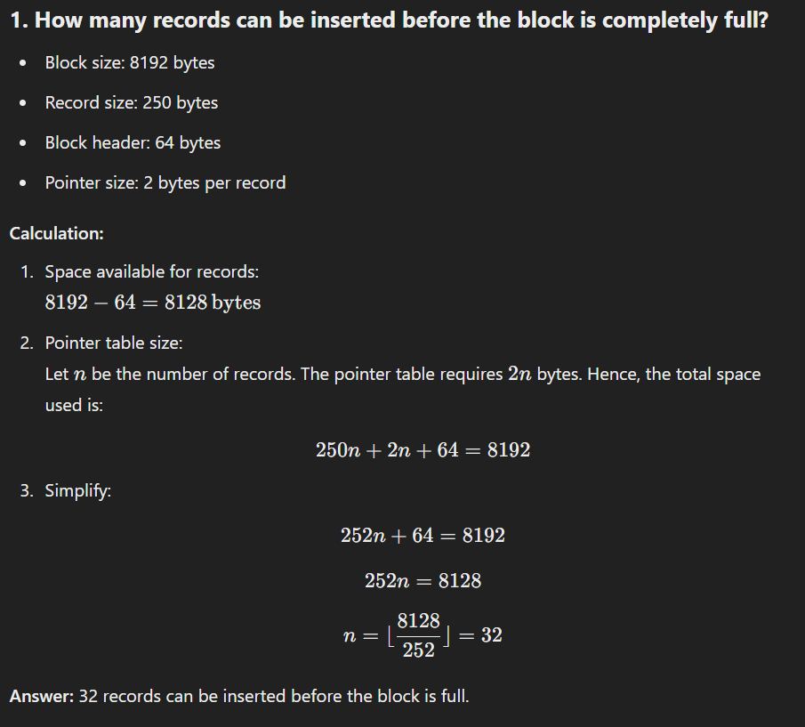

- A data file contains 256 records. The records and blocks follow the configuration described in Exercise 1. How many blocks are required for the data file if:
a) Spanned storage is used.
b) Unspanned storage is used.
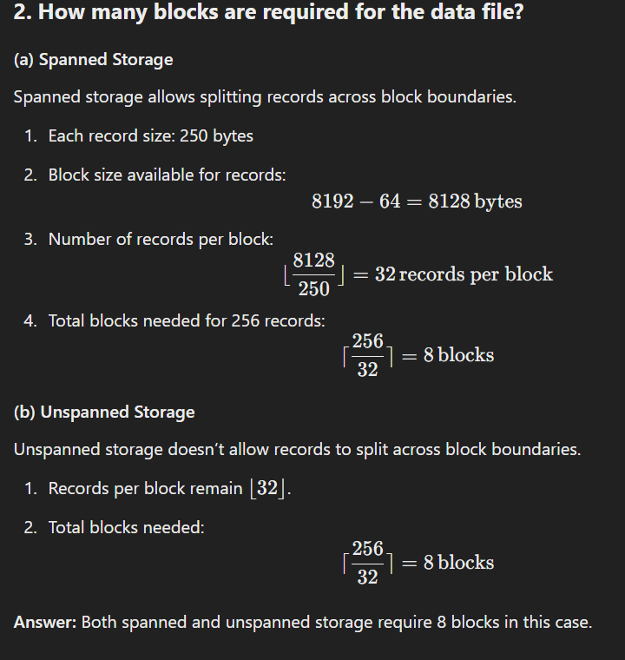

- Suppose we manage a sequential data file with 512 records, using overflow blocks to handle insertions. Assume the primary blocks are initially 75% full. If new records are inserted randomly, how many records must be inserted before the average number of blocks (including overflow blocks) that need to be examined for a lookup reaches 3? Assume the search starts at the primary block and continues through the overflow chain until the record is found.

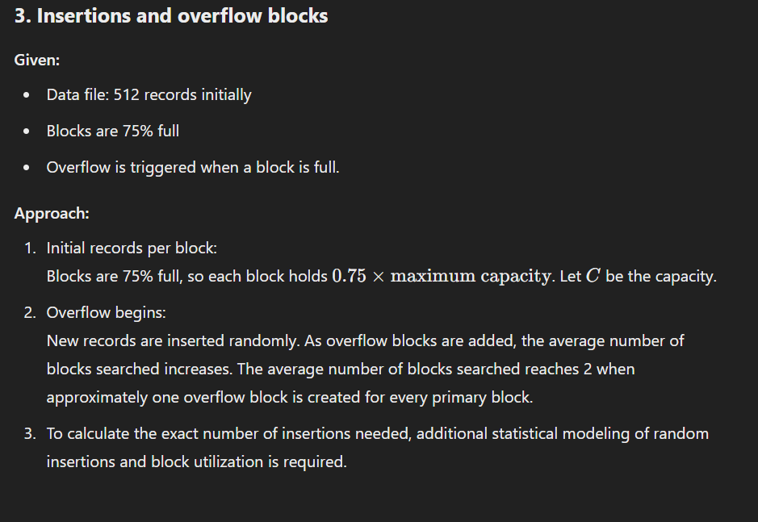

- Blocks can store either five records or 20 key-pointer pairs. Given nnn, the number of records, calculate the minimum number of blocks required for:
a) The data file.
b) A dense index.
c) A sparse index.
You may ignore inaccuracies caused by rounding.

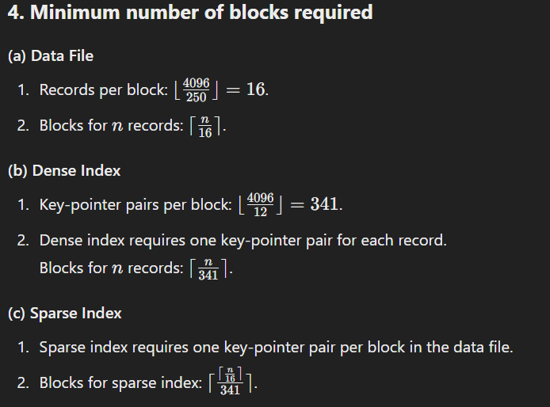

- Consider a block of 4096 bytes used for storing records of size 200 bytes each. The block header is 32 bytes, and an offset table requires 2 bytes per record.
a) How many records can the block store under unspanned storage?
b) If records are deleted at random and tombstones are used, how does this affect the total capacity for new records after 25% of the records have been deleted?

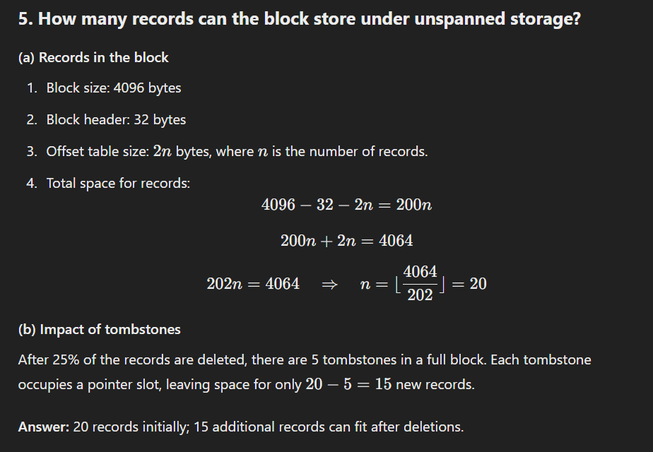

- Suppose a file contains 1 million records and uses a primary index with key-pointer pairs. Each block stores 128 key-pointer pairs, and the key is 8 bytes while the pointer is 4 bytes. Calculate:
a) The number of blocks required for the primary index.
b) The number of blocks required for a sparse index if each sparse key points to a block in the primary index.

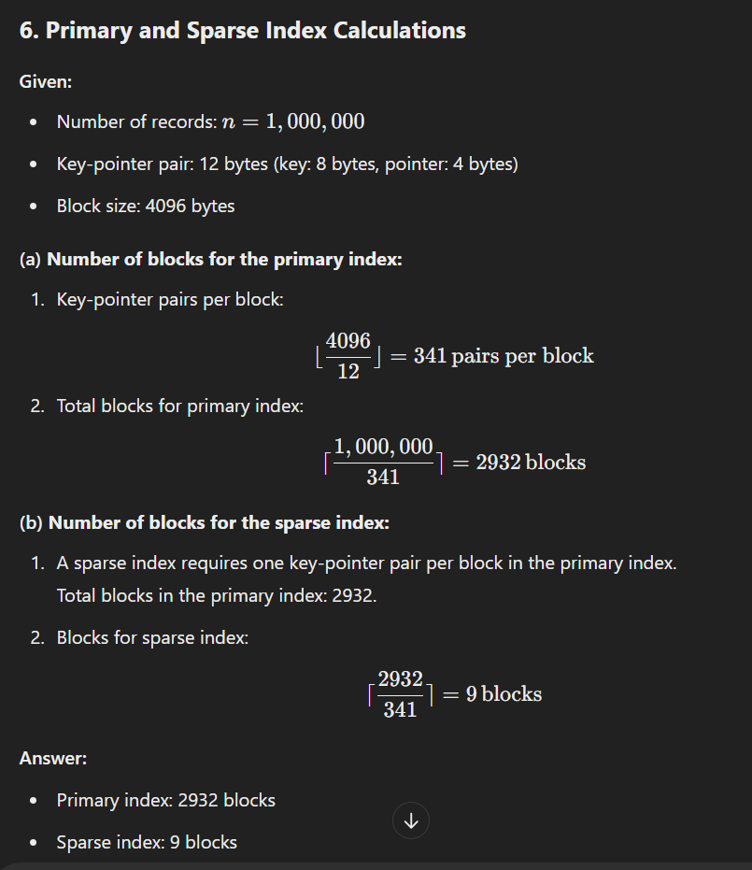

- Imagine you are working with a database system where records of variable lengths are stored using a slotted-page structure. Each slot pointer requires 2 bytes, and the block header is 48 bytes. A block has a total size of 2048 bytes. How many variable-length records can be stored in a block if the average record size is 200 bytes?

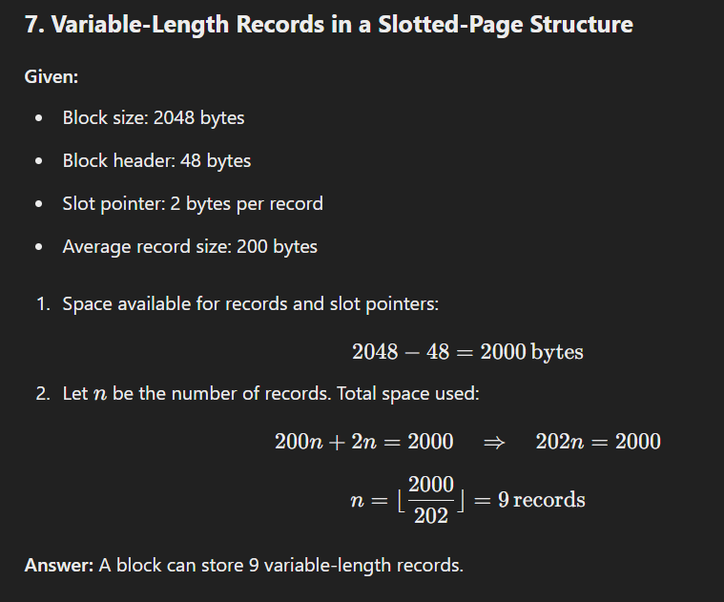

- Consider a block of 8192 bytes with a block header of 128 bytes and a record format as follows:
  - 4-byte integer ID
  - 8-byte double value
  - 2-byte short value
Assume records must align to 4-byte boundaries. How many records can be stored in a single block?
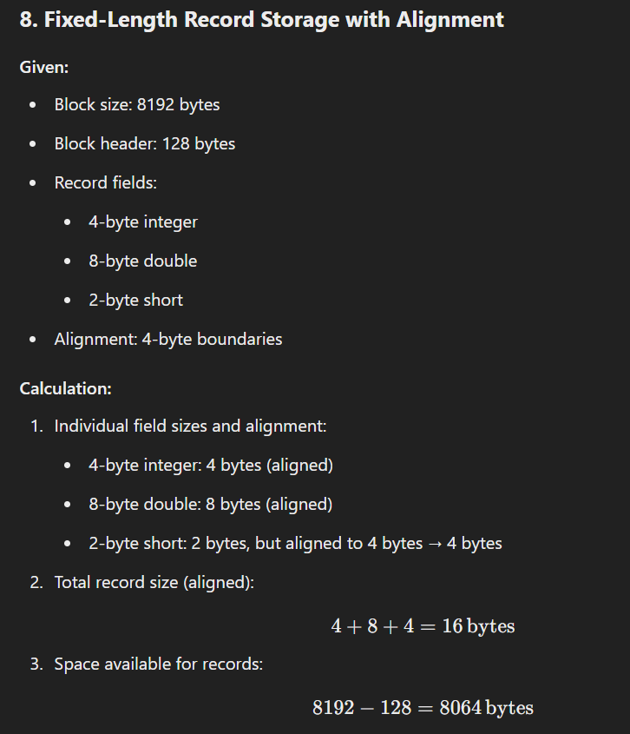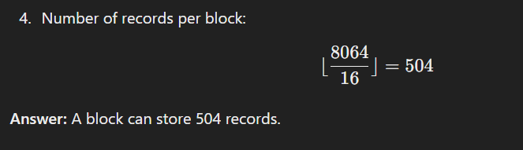

- Discuss the implications of using dense vs. sparse indexes for a database with 10 million records. Consider factors such as the size of the index, lookup time, and block access during searches.
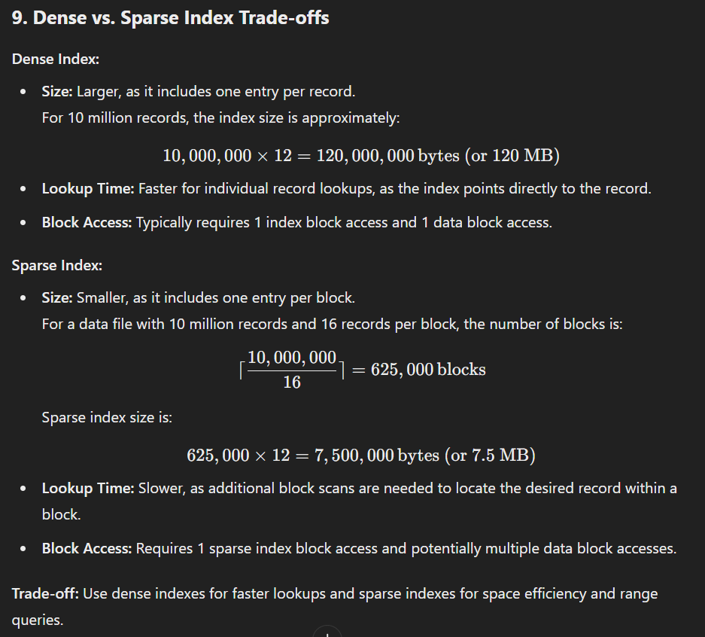

- A file contains n records, and a secondary index is used to support range queries. Each key-pointer pair in the index requires 12 bytes. If the block size is 4096 bytes, calculate the number of blocks required for the secondary index and discuss how the index structure affects range query performance.
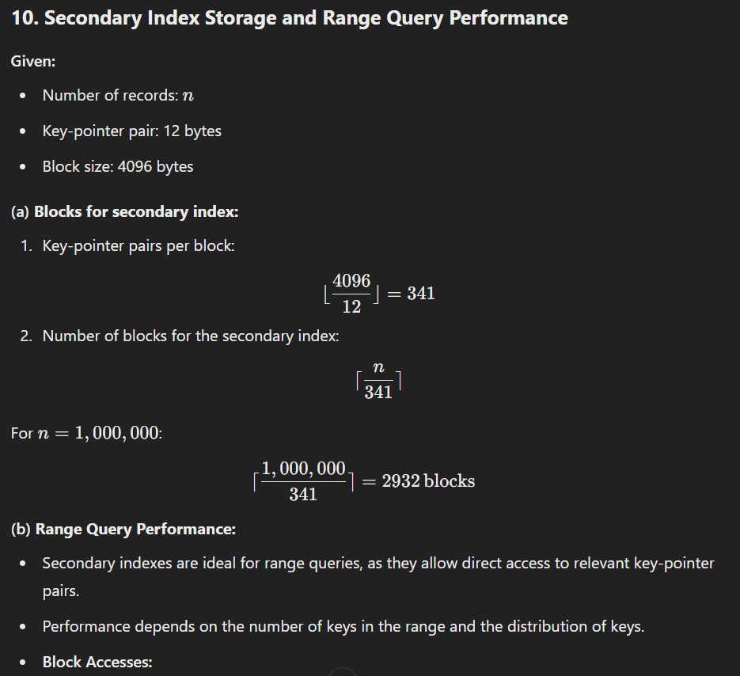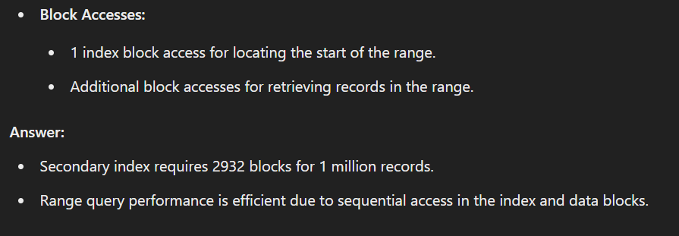

Here are some useful YouTube videos and resources that cover topics similar to the DBMS exercises you are working on:
- Clustered Index in Database with Examples
  - A detailed explanation of clustered indexing with practical examples. Great for understanding primary and clustered index structures.
  - Watch here: Clustered Index in Database - YouTube​
YouTube
.
- DBMS: Index and Index Structures
  - This video introduces index structures, types of indexes, and how they optimize database queries.
  - Watch here: Index and Index Structures - YouTube​
YouTube
.
- Harvard Lecture: Database Storage and Index Structures
  - Covers database storage fundamentals and an overview of index structures, including B-Trees and B+ Trees.
  - Watch here: Database Storage Lecture - YouTube​
YouTube
.
- Database Index Fundamentals
  - A simple and concise explanation of indexing concepts, focusing on how they speed up database queries.
  - Watch here: Index Fundamentals - YouTube​
YouTube
.
- Database Indexing Explained with PostgreSQL
  - Practical demonstration of indexing in PostgreSQL, including types of indexes and performance considerations.
  - Watch here: Indexing with PostgreSQL - YouTube​
YouTube
.
These videos should provide a strong visual and conceptual understanding of index structures, record storage, and related DBMS topics. Let me know if you'd like recommendations for specific articles or courses!

